**Professional Behavior Template Example**

1. **Interacting Professionally with the Instructor:**My interaction with you throughout this course has been minimal, but I did my best to try and be civil, professional, and formal in my writing to you. As an example, here’s an excerpt of the last email I submitted to you: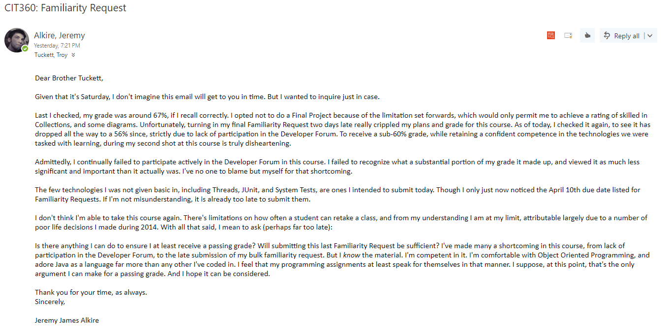
2. **Interacting Helpfully and Professionally with Other Teams:**Though my interaction with classmates was minimal, I did my best to be civil and helpful during the few times in which we interacted. My lack of participation in the Developer Forum was my own fault, and no one else’s.
3. **Supporting the Team by Teaching, etc.**I’ve not done anything additional to teach other students since my last familiarity request. Although, if I’m permitted to work on a final project, I can certainly create a video that comprehensively reviews some of the technologies we’ve worked on, and adds additional design tips (or reviews of different design patterns) to assist them in their projects.
4. **Self-Reflection/Meta-Cognition:**There’s much to reflect on this semester, for me. A large part of my issue has stemmed from poor time management coupled with a poor sleeping schedule. I could go into great detail about this, but in short – I can and need to do much better in the future.  
     
   Regarding this course: I’m perfectly comfortable with programming, and sincerely looked forwards to the final project, previous to discovering that my late submission would exempt me from ability to try and prove skilled proficiency in all but one programming technology. My greatest struggle was environment set up, coupled with a slew of issues that stemmed from Tomcat not deploying class updates properly. But I eventually figured it all out, and everything works as intended now! Barring that, the greatest obstacle to me receiving a high grade in this course was myself, and my poor management of time.
5. **Team's Agile Methodology:**Our team chose the scrum methodology. Though we don’t meet via video daily, we do chat daily in our hangouts group. I’ve not participated in these group chats as much as I should have.
6. **Professional Scheduling Group:**To my knowledge we don’t have a specific schedule regarding teaching topics. As it was told to me, when we meet, whoever teaches is dependent upon who knows a certain subject, and what they feel comfortable with teaching at that time. We try to meet by Wednesday each week.  
     
   I’ve missed most of these meetings.